SECTION A

Question 1 – 10 are based on the information given.

Question 1
Read the sign below and answer the question that follows.

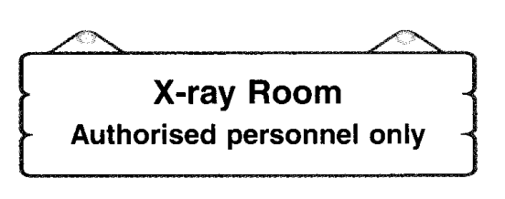

1 Who are not allowed into the X-ray room?

A Nurses
B Doctors
C Patients
D Hospital attendants

Question 2
Read the dialogue below and answer the question that follows.

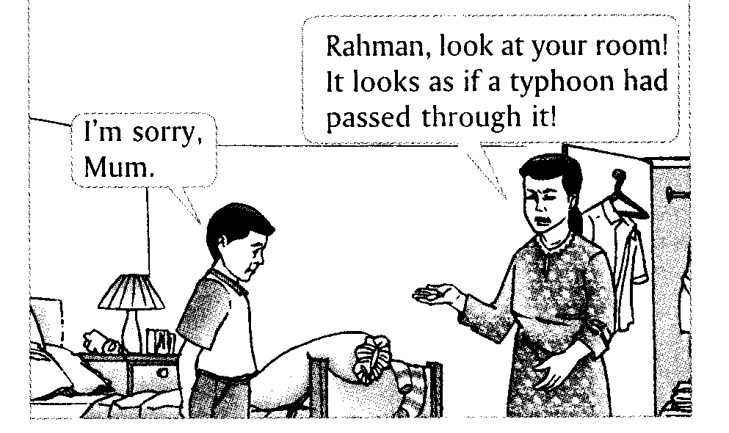

2 From the dialogue, we know that

A the wind was strong last night
B Rahman must be lazy and untidy
C Rahman is spring-cleaning his room
D a typhoon had passed through the room

Question 3
Study the cartoon below and answer the question that follows.

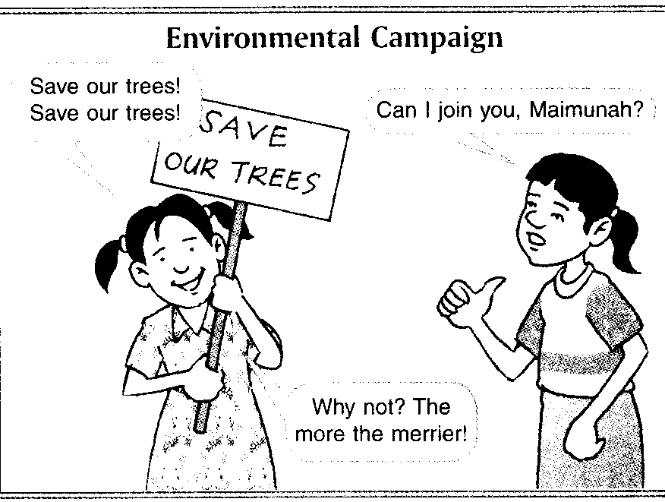

3 From the cartoon, we know that Maimunah

A welcome Vivien to join her in the campaign
B thinks that Vivien should not join the campaign
C does not want Vivien to join her in the campaign
D says that there are already too many people involved in the campaign

Question 4
Study the notice below and answer the question that follows.
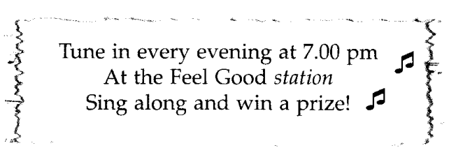

4 What does the word station refer to?

A A bus station
B A radio station
C A railway station
D A television station

Question 5
Study the advertisement below and answer the question that follows.
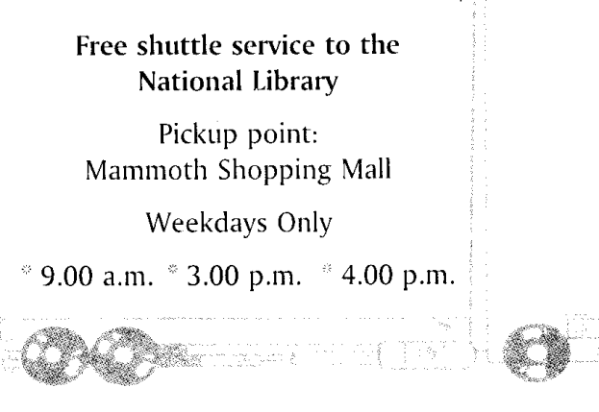

5 What service is provided in the advertisement above?

A Shopping
B Book loan
C Transport
D Book delivery

Question 6
Study the report below and answer the question that follows.

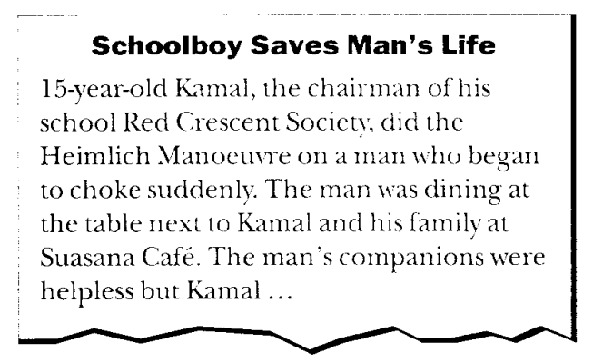

6 From the report, we understand that the Heimlich Manoeuver

A can save a person’s life
B should be taught to every student
C is regularly done at the Suasana Café
D is only taught to Red Crescent members

Question 7
Study the pie chart below and answer the question that follows.
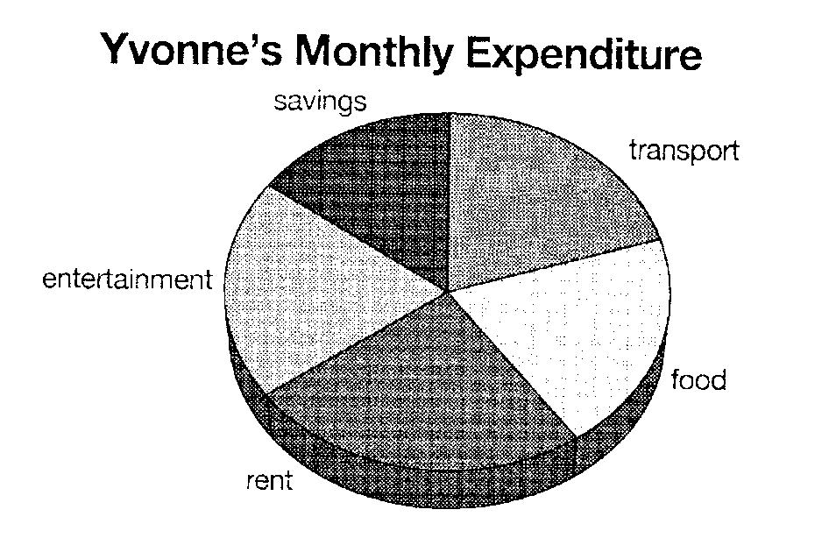

7 To pay a subscription of Lifestyle Magazine, Yvonne would probably use money from

A rent
B savings
C transport
D entertainment

Question 8
Study the poster below and answer the question that follows.

8 Which of the following is true?

A The organizer only accepts cash or cheques.
B All the money collected is for the students of SMK Sri Aman
C The organiser welcomes students who wish to help sell things at the Jumble Sale
D The Jumble Sale will be held at Banting Cheshire Home

Question 9
Study the bar graph below and answer the question that follows.
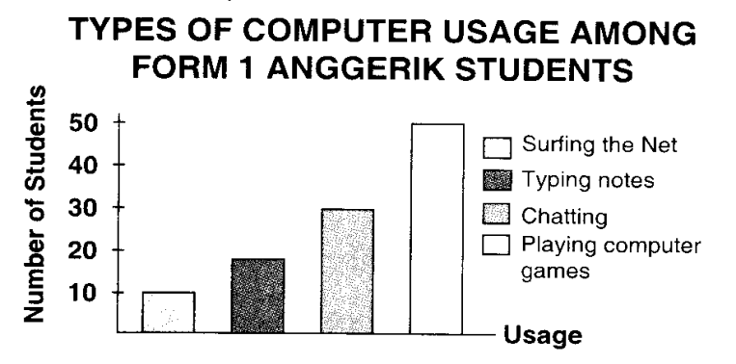

9 Most of the students like to

A chat
B type notes
C surf the Net
D play the computer games

Question 10
Study the comic strip below and answer the question that follows.
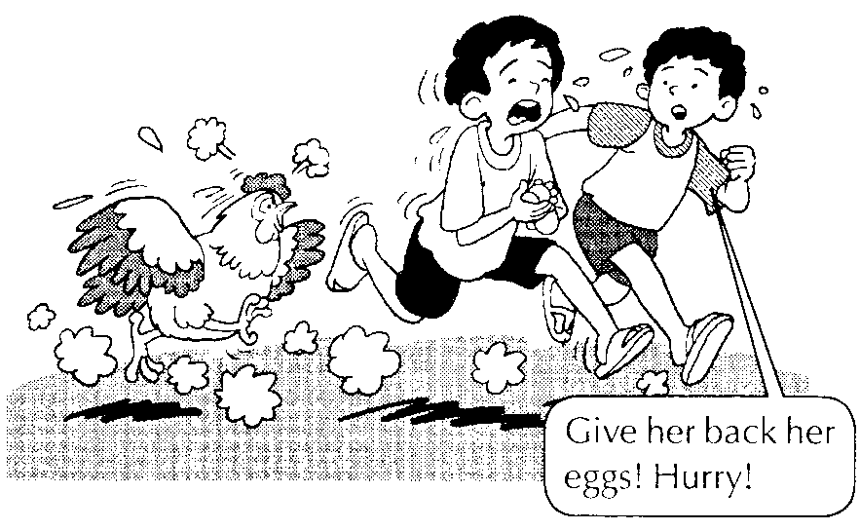

10 From the comic strip above, we can conclude that the

A mother hen is angry
B boys are not afraid of the chicken
C mother hen wants her chicks back
D two boys are playing with the chicken

SECTION B
Question 11 – 18
Each question in the text below refers to a numbered blank. For each question, choose the best answer from the options A, B, C and D to fit the numbered blank.
A wolf ___ (11) it hard to get a sheep because of the sharp eyes of the shepherd and his dogs. ___ (12), one day, it found the skin of a sheep ___ (13) the ground. It quickly put it on over ___ (14) own fur and strolled among the sheep.
The lamb, thinking that it was its mother, began to ___ (15) the wolf in the sheep’s clothing. So, leading the lamb away, the wolf soon ___ (16) her up. For some time, thanks to the sheep skin, ___ (17) wolf succeeded in deceiving the sheep and had ___ (18) hearty meals.

11 A find 15 A follow
B finds B follows
C found C followed
D finding D following

12 A Soon 16 A ate
B However B eat
C Although C eats
D Moreover D eating

13 A on 17 A -
B up B a
C in C an
D over D the

14 A it 18 A some
B it’s B many
C its’ C more
D its

SECTION C

Questions 19 – 21
Read the letter below and choose the best meaning for the phrases that are underlined.

Dear teacher,
I hope you are not disappointed with me. I’m sorry for not handing in my homework on time (19). As you know, I’m in the school football team. I was away training for the inter-school football match and now I cannot keep up with (20) the lessons in the class. My homework has piled up as well. I find that I’m short of (21) time and cannot complete all my assignments. I hope you will forgive me this time.

Your student,
Chambing

19 on time

A at another time
B at the same time
C at the usual time
D at the expected time

20 keep up with

A work
B practise
C show
D manage

21 short of

A useful
B mistake
C lack
D require

Questions 22 – 24
Read the conversation below and choose the best meaning for the phrases that are underlined.

MR. CHIN : I regret spending so much money to buy that organ for Julian. Look at it now. It’s just there collecting dust (22).

MRS. CHIN : Why do you say that, Joe?

MR. CHIN : Well, I hardly see Julian practising on his organ. The last time he did was about three months back, right?

MRS. CHIN : Give him a break (23). I think he’s taking time off from music right now. After all, he just sat for the Grade 4 examination, remember?

MR. CHIN : That was three months ago! How long of a break does he need? I think I’ll have a talk with him. If he isn’t interested to play organ any longer, I’ll sell it off.

MRS. CHIN : Wait a minute, isn’t that Julian playing the organ? Now you have to eat your words (24)!

22 collecting dust

A looking dirty
B not being used
C becoming dusty
D taking so much space

23 Give him a break

A Give him a chance
B Make sure he rests
C Give him a scolding
D Make him work harder

24 eat your words

A keep quiet
B leave him alone
C apologise to him
D admit that you were wrong

SECTION D

Question 25 – 28
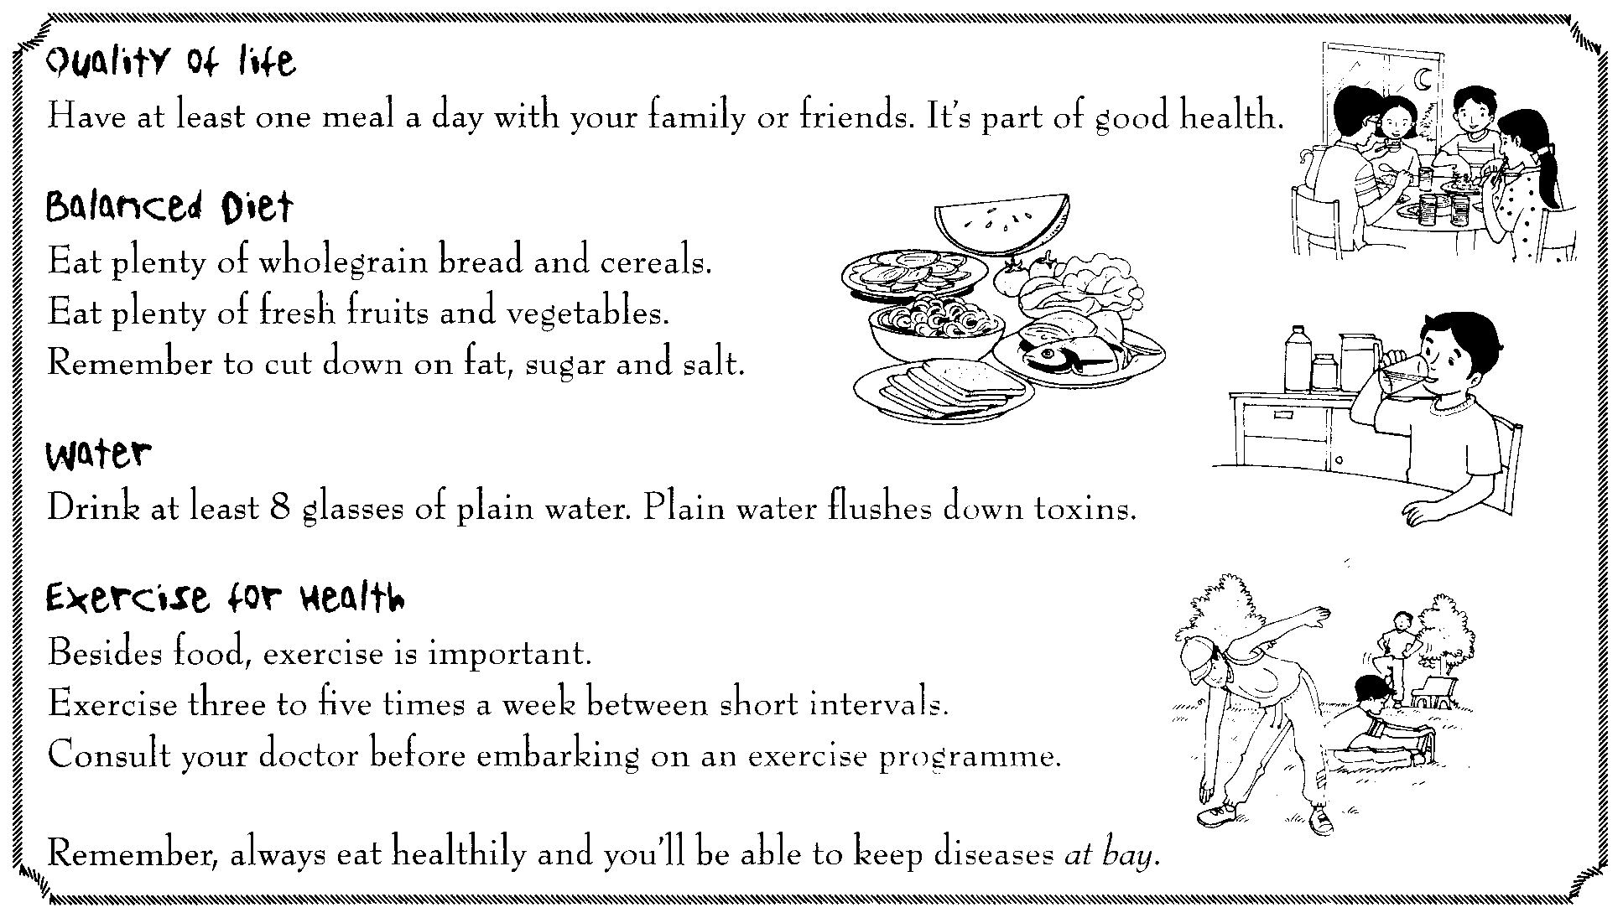
Study the poster below and choose the best answer for the questions that follow.

25 The best title for the poster above would be

A Eating and Drinking
B Food and Exercise
C Food and Health
D Eat Well

26 Why is it important to have at least one meal a day with family members or friends?

A It is more enjoyable
B For a qualitative life
C To be able to share food
D To be a cultivated family

27 Water is important because

A it is pure
B it is natural
C it helps us to survive
D it flushes down toxins

28 The phrase at bay means

A coming
B away
C out
D in

Questions 29 – 34
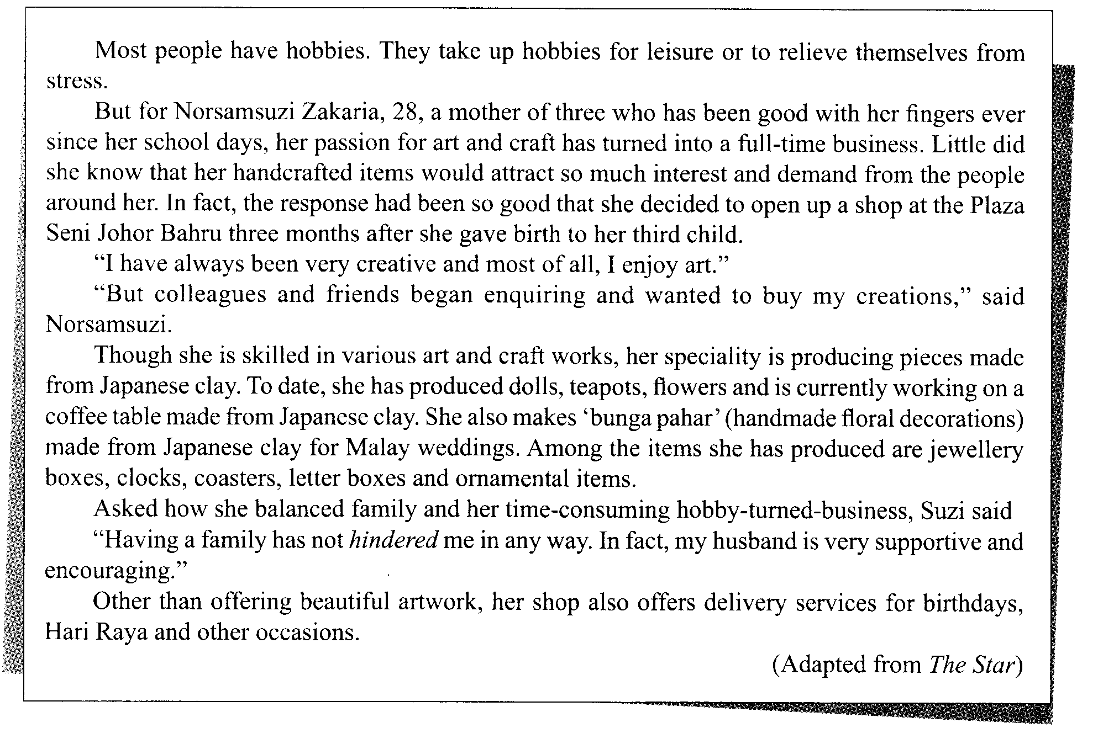
Read the passage below carefully and choose the best answer for the questions that follow.

29 How many children does Norsamsuzi have?
A One
B Two
C Three
D Four

30 Norsamsuzi is currently
A an art teacher
B an office worker
C a business woman
D a full-time housewife

31 People usually take up hobbies for
A diet
B health
C leisure
D business

32 If one wants to meet Norsamsuzi, he or she has to
A e-mail her
B see her in her home
C go to Plaza Seni Johor Bahru
D see her at her husband’s office

33 The word hindered can be replaced with
A made
B learned
C noticed
D prevented

34 What made Norzamsuzi open up a shop?
A She needed a job
B Her husband’s idea
C She was facing financial problems
D There was much demand for her work

SECTION E
Questions 35 – 37
Read the poem below carefully. Then, choose the best answer for the questions that follow.
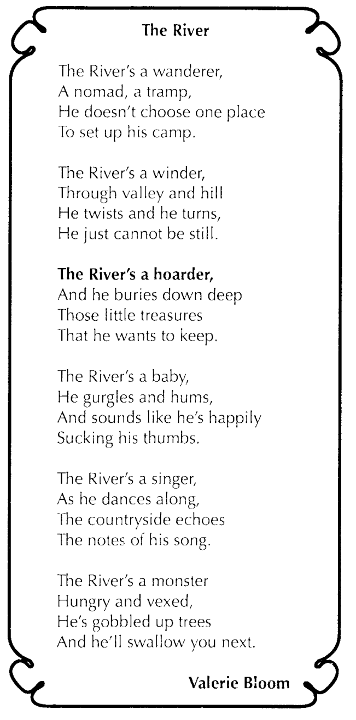

35 The line The River’s a hoarder indicates that the persona is someone who

A is cheerful
B keeps secrets well
C enjoys good fortune
D has a lot of treasures

36 A river cannot be still because
A it wants to wind
B it is always flowing
C it likes to twist and turn
D it passes through valleys

37 The song of the river refers to the sounds of the
A boats
B water
C swimmers
D countryside

Question 38 – 40
Read the extract from the Flipping Fantastic and answer the following questions.
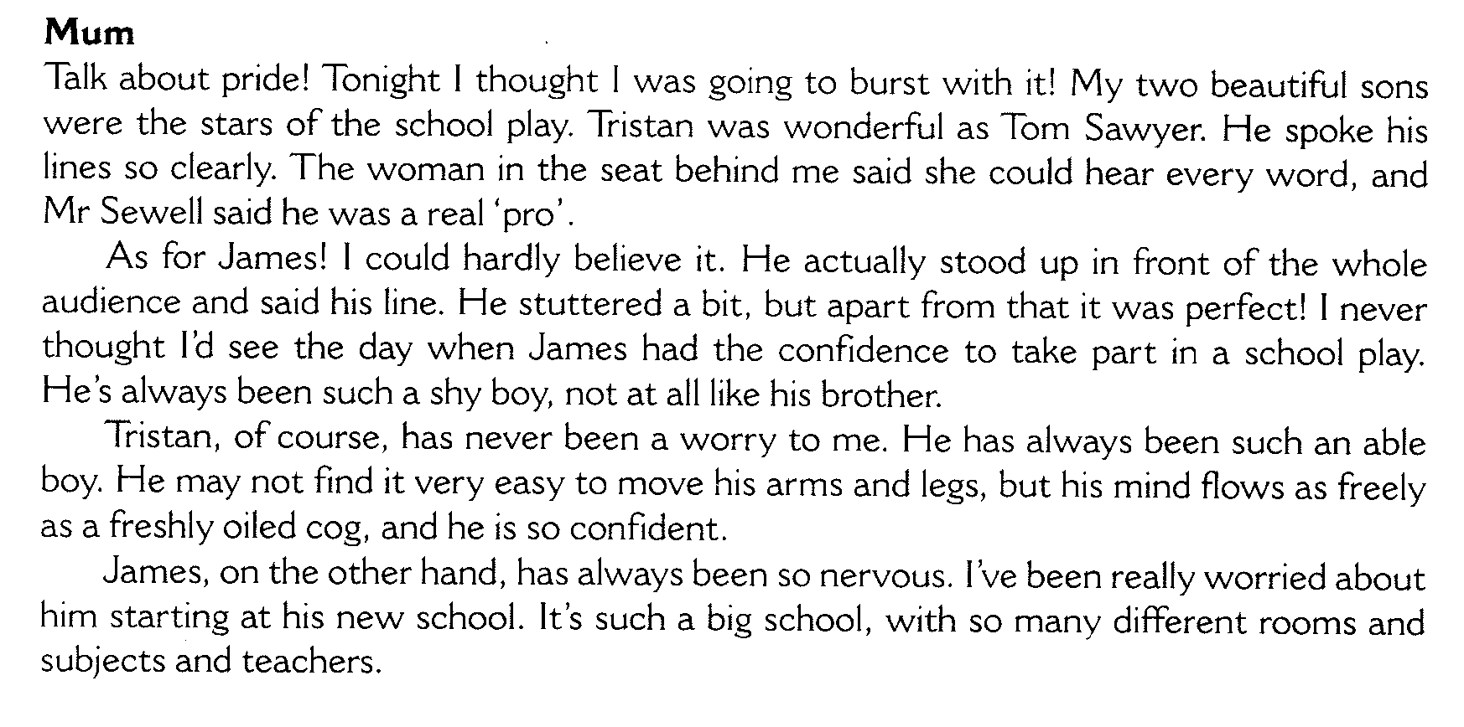

38 Who is Tom Sawyer in the school play?

A A main character
B A minor character
C A female character
D A disabled character

39 Why is the mother bursting with pride?

A Her sons were beautiful
B Her sons did very well in the exam
C Her sons were the stars in the play
D Her sons play the main roles in the play

40 What does the mother find hard to believe?

A Tristan was wonderful as Tom Sawyer
B Mr Sewell said Tristan was a real ‘pro’
C James’ line was absolutely perfect
D James actually said his line in front of an audience

- END OF TEST PAPER -

