SECTION A
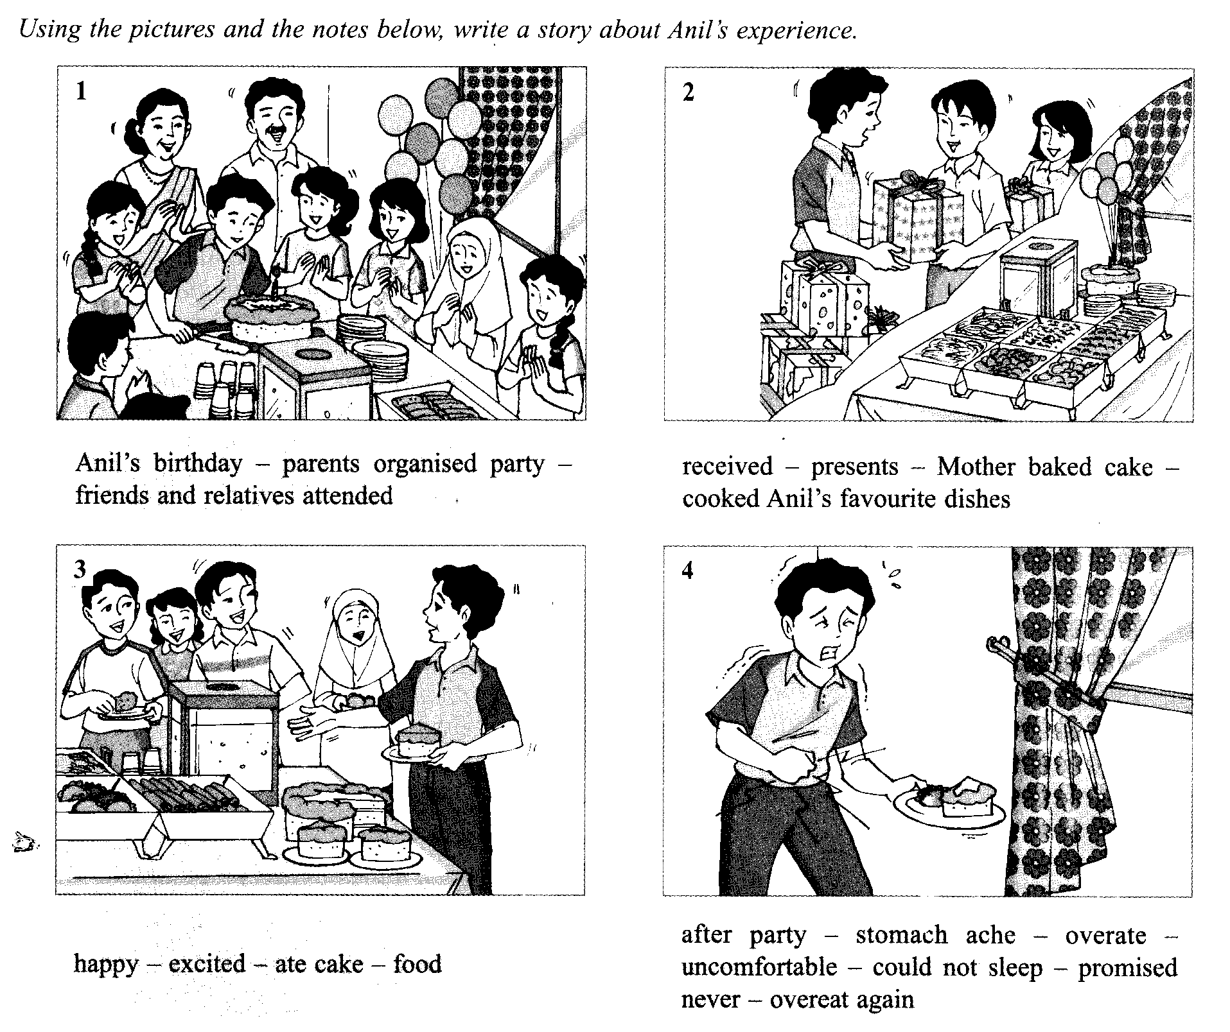
(30 marks)

When writing your story:
- You may use all the notes given.
- Elaborate on the given notes to make it more interesting
- Make sure it is not less than 120 words.

SECTION B

(10 marks)

Read the passage below and answer the question that follows.

There are many reasons why we should exercise regularly. Regular exercise helps to reduce many types of sickness. It reduces the risk of diabetes, high blood pressure and certain forms of cancer. It also reduces the level of cholesterol in the blood. A person with too much cholesterol in his blood can suffer from a heart attack or stroke.
Regular exercise improves our general health. It strengthens the bones and muscles. It makes the heart muscles stronger so that the heart can pump blood more efficiently to all parts of the body. People who exercise regularly are also more energetic or active.
As all of us know, regular exercise helps to control weight. It turns off fat so that any extra food that we take in will not be stored as fat.
Another benefit of regular exercise is it improves mental health. It reduces stress and helps us to relax. It has been found that children who exercise regularly are more cheerful and have more self-confidence. They even perform better in their studies.

Write a summary on the importance of regular exercise.

Your summary must:
- Not be more than 60 words including the 10 words given below.
- Be in continuous writing (not in note form)
- Be written in one paragraph.

Begin your summary as follows:

Exercising regularly helps to reduce sickness such as diabetes, cancer …

Follow the steps given to help you do your summary.

STEP 1:
The diagram below helps you to mind map your points.

The Importance of Regular Exercise
Reduces cholesterol level
Reduces sickness
diabetes
Helps one to relax
5 …
Burns off fat
1 …
4 …
3 …

2 …
the heart muscles comes stronger
high blood pressure

cancer

STEP 2:
Use your own words as far as possible without changing its original meaning. The table below helps you to count your words.

Exercising | regularly | helps | to | reduce | sickness
such | as | diabetes, | cancer

(……….. words)
STEP 3:
Write out the summary in ONE paragraph with not more than 60 words in your answer sheet.

SECTION C
(10 marks)

From the graphic novel, Journey to the Centre of the Earth, describe any one of these interesting characters in not less than 50 words.

Axel
Professor Otto Lidenbrock
Hans Bjelke

