SECTION A
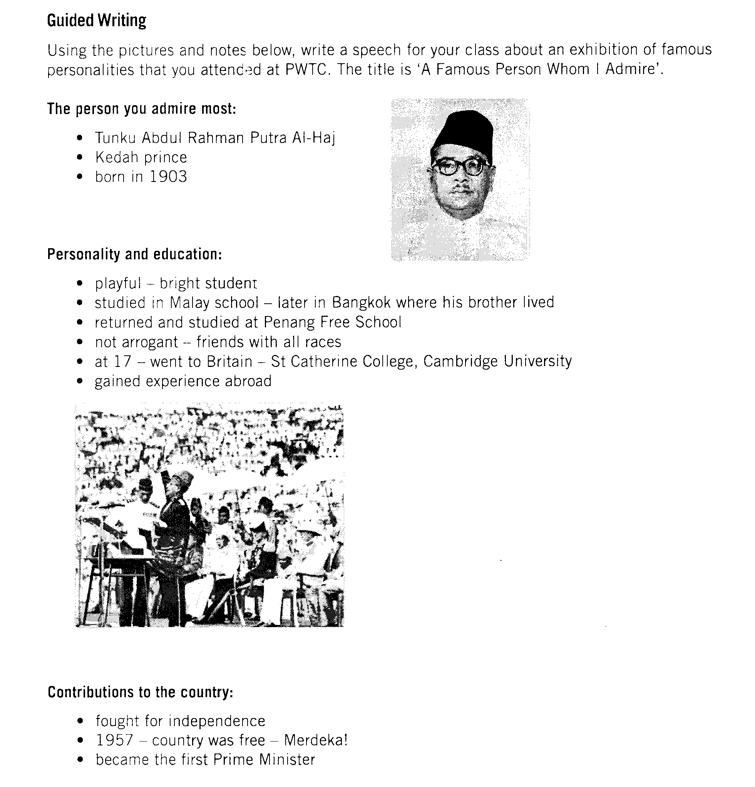
(30 marks)
When writing your speech:
- you may use all notes
- elaborate on the given notes to make it more interesting
- add any other relevant information
- make sure it is not less than 120 words
SECTION B

(10 marks)

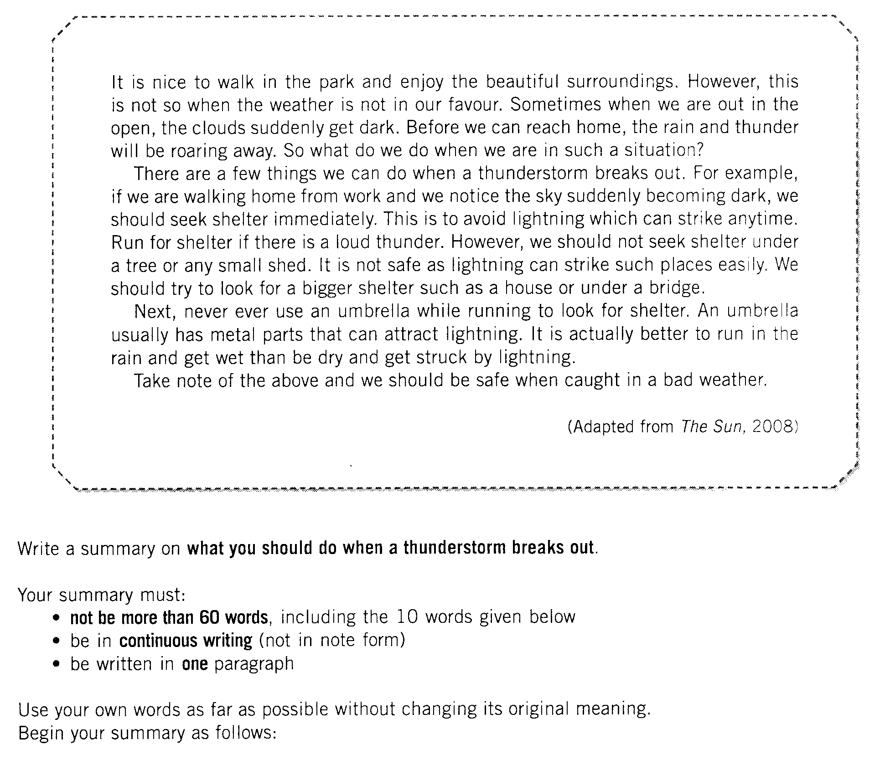
Read the article and complete the following task.
When the clouds get dark, it means that there will…

SECTION C

(10 marks)

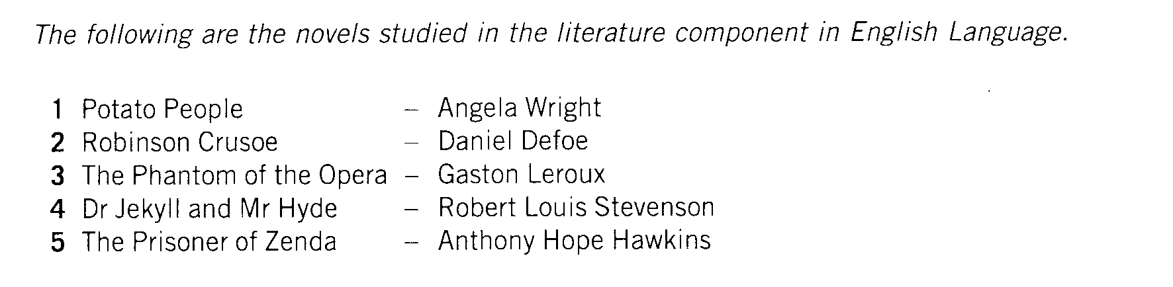

Based on one novel you have read, write about an event that is full of suspense.

Support your answer with evidence from the novel.

Your response should be:
- not less than 50 words.
- in continuous writing (not in note form)

